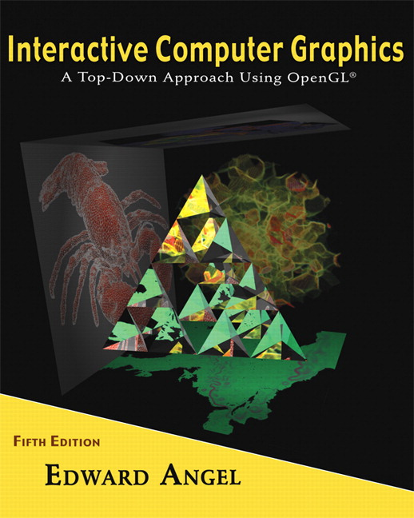 COSC 4370
Name: ____________________ TERMINAL NUMBER ____
Programming Assignment 3 Acceptance Testing:

After you downloaded your zipped project from BB and rebuilt it using the 200 PGH Visual Studio 2010, take screenshots of the output produced, and insert it in this file ……..
Lighting and Shading:
1. Place spot light at top inside right initial direction towards the center of the BUS.
SCREENSHOT Output of your program is:
……..

2. Move light at front left.
SCREENSHOT Output of your program is:
……..

3. Move light at front middle.
SCREENSHOT Output of your program is:
……..

4. Move light at front right.
SCREENSHOT Output of your program is:
……..

5. Move light at middle side left.
SCREENSHOT Output of your program is:
……..

6. Move light at middle side middle.
SCREENSHOT Output of your program is:
……..

7. Move light at middle side bottom.
SCREENSHOT Output of your program is:
……..

……..

Texturing:
1. Texture your BUS by using either a texture similar to the actual BUS or any other BUS siding textures or bump mapping.
SCREENSHOT Output of your program is:
……..

Words on the BUS:
1. SCREENSHOT Output of your program is:
……..

Navigation:
1. Discrete reposition & orientation of the light should be linked to a menu, key.
SCREENSHOT Output of your program is:
……..

2. Second, the LookAt needs to be amended with the following camera positions:
at the DOOR looking toward the middle back BUS
SCREENSHOT Output of your program is:
……..

Copy and paste LookAt from your code for this position here:
………

3. Second, the LookAt needs to be amended with the following camera positions:
in the middle of the BUS looking at the DOOR
SCREENSHOT Output of your program is:
……..

Copy and paste LookAt from your code for this position here:
………
Source Code:
1. Copy and Paste your .c (.cpp) file here:
…….

When done attach this file to “Testing Programming Assignment 2” BB assignment.

